## **Appendix A: Interview Transcript**

**Interviewer:** Tshiamo Galefete  
 **Interviewee:** Kentsenao Baseki  
 **Date:** 09/18/25  
 **Mode:** Online

**Functional Requirements**

### **Q1. What core services must the system provide?**

**A:** The system should allow users to create and manage accounts, perform deposits and withdrawals, transfer funds, check balances, and generate transaction histories. It should also handle interest calculations for savings accounts.

### **Q2. What is the main purpose of the system?**

**A:** The main purpose is to provide a secure, reliable, and user-friendly way for customers to manage their finances digitally, while also helping the bank reduce manual work and errors.

### **Q3. Who will use this system?**

**A:** The primary users will be customers (account holders). Secondary users include bank staff (tellers, managers, support staff) who may need to authorize transactions, monitor activity, or generate reports.

### **Q4. How should the system handle mistakes or errors?**

**A:** The system should provide clear error messages when users make invalid inputs, and allow them to correct mistakes. For critical errors (e.g., failed transactions), the system should log the error, notify the administrator, and ensure no money is lost.

### **Q5. What type of accounts should the system support?**

**A:** The system should support at least savings accounts, current accounts, and business accounts. Later, it may expand to support loan accounts and student accounts.

### **Q6. What are the most critical operations the system must perform daily?**

**A:**

* Processing deposits and withdrawals in real time.
* Executing fund transfers securely.
* Updating balances instantly.

**Non-Functional Requirements**

### **Q1. How important is security for the system?**

**A:** Security is critical. The system must protect customer data, prevent unauthorized access, and use encryption for sensitive information like passwords and account numbers.

### **Q2. What performance expectations do you have for the system?**

**A:** The system should process transactions in real time. Customers shouldn’t have to wait more than a few seconds for deposits, withdrawals, or balance inquiries to complete.

### **Q3. How important is system reliability and availability?**

**A:** Very important. The system should be available 24/7 with minimal downtime. Backup and recovery mechanisms must be in place to prevent data loss.

### **Q4. How user-friendly should the system be?**

**A:** The interface should be intuitive for all customers, including those who are not tech-savvy. Clear instructions and error messages are essential to reduce confusion.

### **Q5. What about maintainability and future updates?**

**A:** The system should be easy to maintain and update. Adding new features or fixing bugs should not disrupt daily operations.

### **Q6. Are there any legal or compliance requirements?**

**A:** Yes, the system must comply with banking regulations, data privacy laws, and audit requirements. All transactions must be traceable and secure.

**USE CASE DIGRAM**

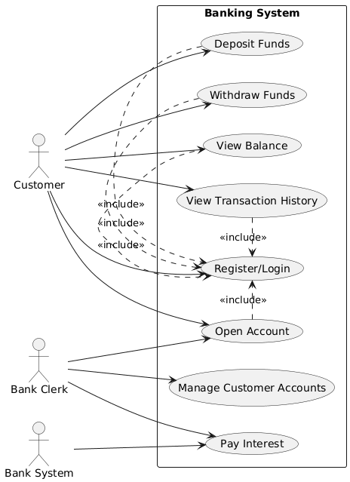

CLASS DIAGRAM

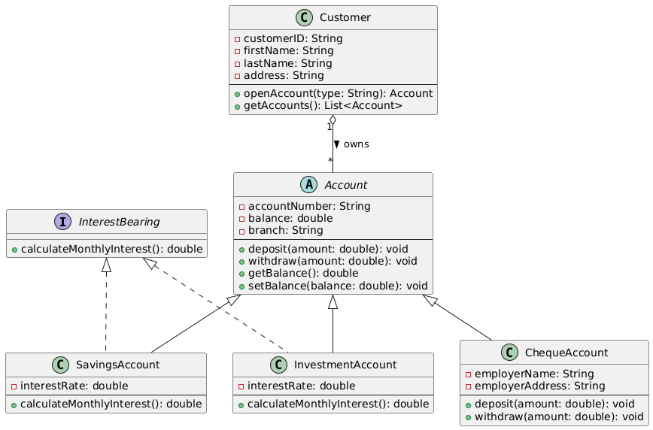

SEQUENCE DIAGRAMS

Deposit funds Use case

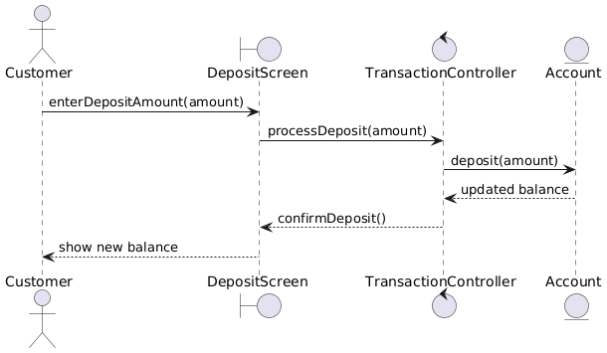

Login Use case

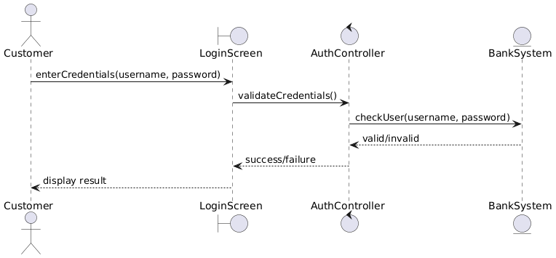

STATE DIAGRAM

